**Kick-off Meeting**

**17.-18. October 2022, Leipzig**

**CRC / TRR241 Newsletter**

**Issue 11 - October 2022**

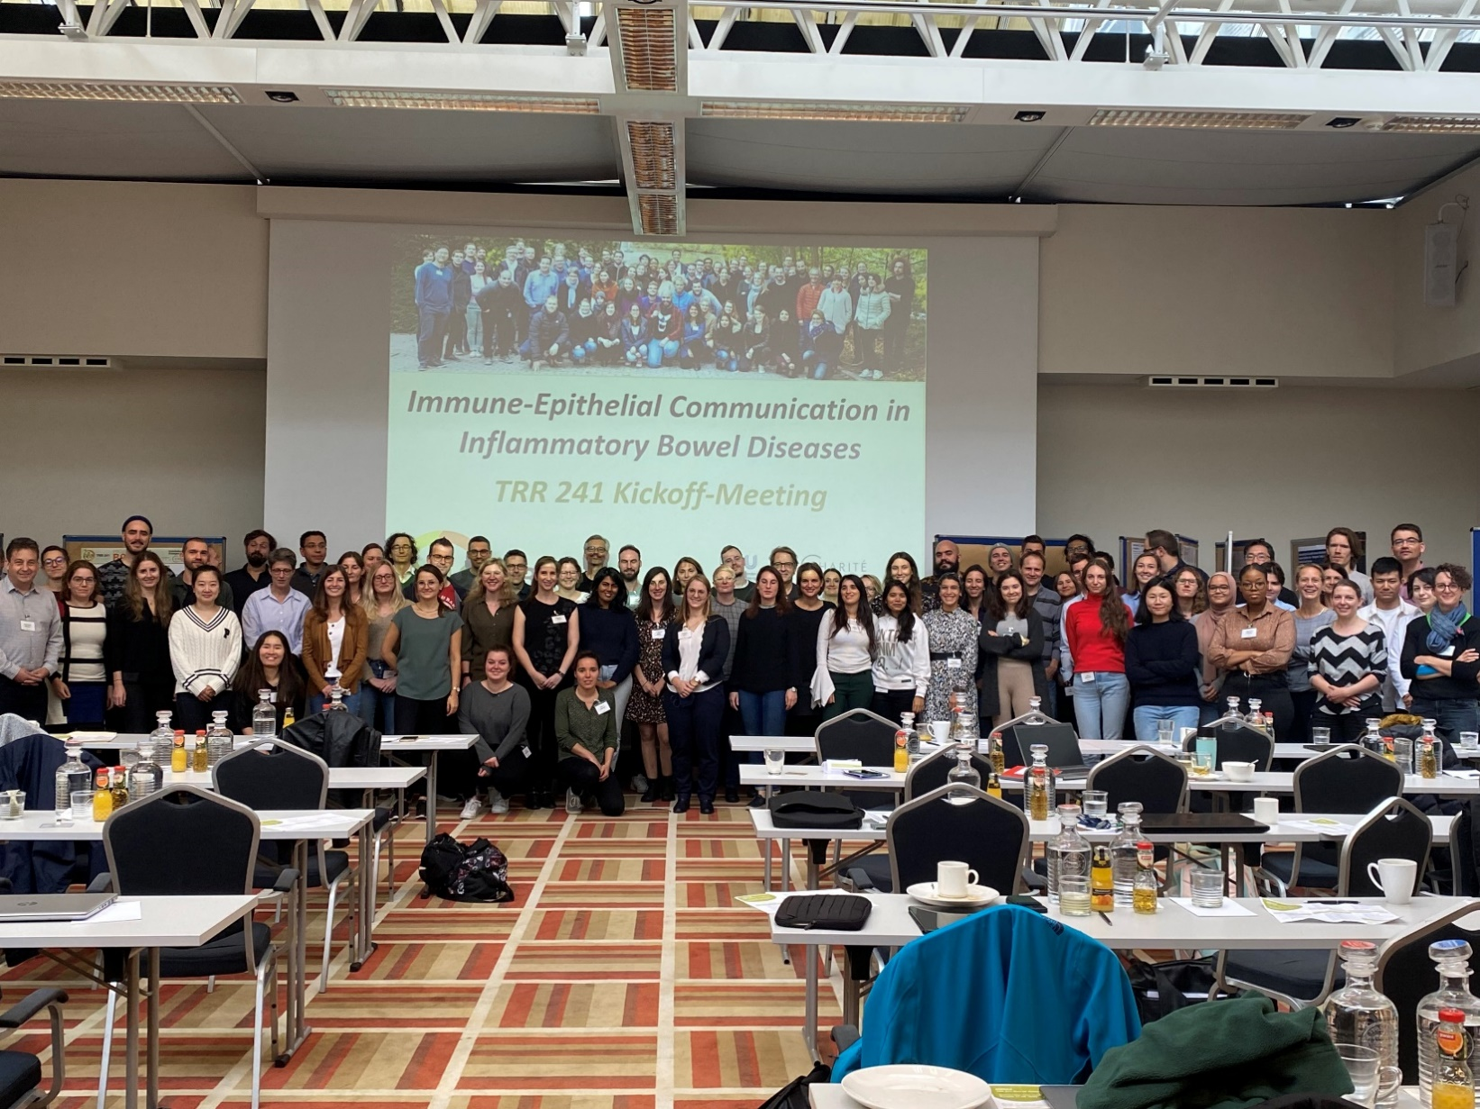

**Kick-off Meeting**

**17.-18. October 2022, Leipzig**

Our kick-off meeting for the 2nd funding period of the TRR 241 took place from 17-18.10.2022 in Leipzig, at the Radisson Blue Hotel. All projects presented their research briefly and we thank all participants for the helpful discussions and suggestions for improvement.

In the project leaders' assembly, Prof. Becker was re-elected as *spokesperson* of the TRR 241, and Prof. Siegmund was re-elected as *co-spokesperson*. Furthermore, Dr. Imke Atreya was re-elected as *Coordinator of Equal Chances Measures*. The Executive Board was re-elected with the same members as in 2018. The student representatives will be elected in the upcoming iRTG Meeting.

We would like to thank *Nicola Gagliani* for his exciting keynote lecture and the insight into his research at the University Medical Centre Hamburg-Eppendorf.

Integrated into the kick-off meeting was the iRTG meeting, which also hosted a poster session. Poster prizes were awarded for the best posters and we congratulate *Lena Erkert*, *Roodline Cineus* and *Martina Macino* for their outstanding performances.

***We would like to thank all the participants for the constructive discussions, the lively exchange and the opportunity to meet all of us again in persona!***

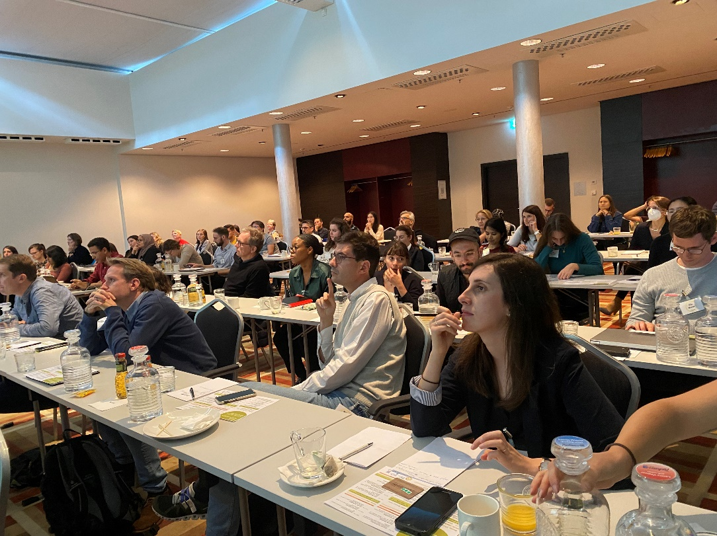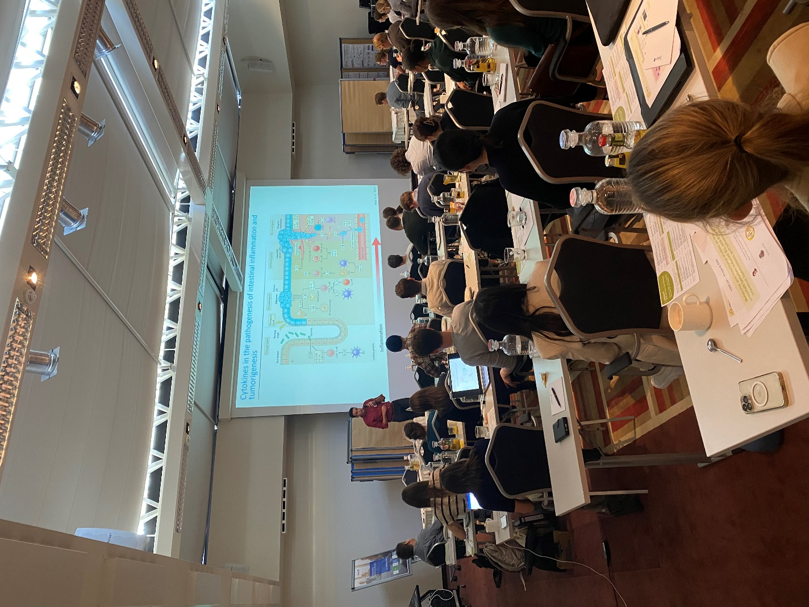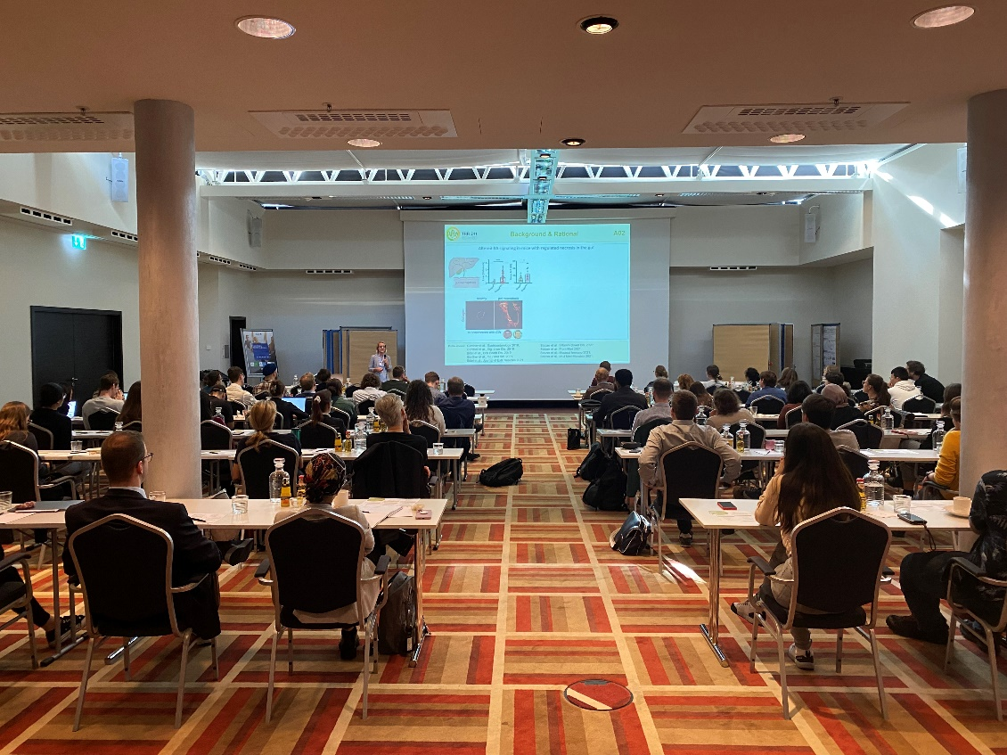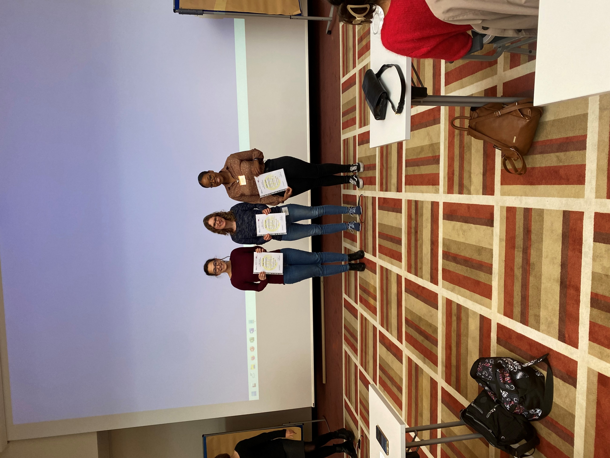

**TRR 241 International Symposium “Vision 2030”**

Please save the date for the next TRR 241 ***International Symposium “Vision 2030”***, which will be held in Berlin at the *Katholische Akademie Berlin* on the ***19th-20th May 2023***.

Further information will follow.

Please send your suggestions for guest speakers to [mailto:eva.liebing@uk-erlangen.de?subject=Vision 2030 guest speaker](mailto:eva.liebing@uk-erlangen.de?subject=Vision%202030%20guest%20speaker)

Please use this great tool to inform yourself about gene expression in IBD-related mouse models!

***URL:http://trr241.hosting.rrze.uni-erlangen.de/SEPIA_API/#!/***

***Username: Guest***

***Password: TRR241***

If you need further information about the tool, the mouse models or if you have any suggestions regarding this tool please contact [mailto:Miguel.GonzalezAcera@uk-erlangen.de?subject=SEPIA webpage](mailto:Miguel.GonzalezAcera@uk-erlangen.de?subject=SEPIA%20webpage)

**SEPIA webpage**

**New TRR 241 members**

Please welcome the new TRR 241 PI Ashley Sanders from the MDC / BIH Berlin. She will work on “Characterizing the impact of somatic mustation in immune and epithelial communication in ulcerative colitis” in project A09 together with Carl Weidinger.



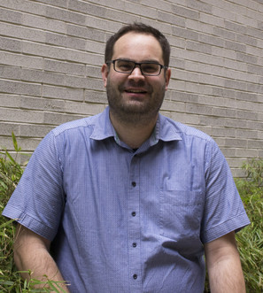

Please welcome the new TRR 241 PI Christoph Klose from Charité. He will work on the “Impact of Epithelial dysfunction on neuro-immune crosstalk in IBD” in project B05 together with Jay Patankar.

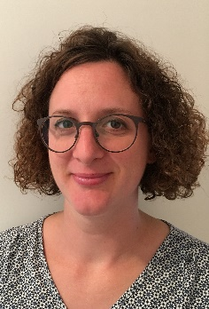

Please welcome the new TRR 241 PI Francesca Ronchi from Charité. She will work on “Dissecting the role of epithelial inflammasome activation in regulating immune responses in colitis” in project B03 together with Hyun-Dong Chang.



Please welcome the new TRR 241 PI Leif Ludwig from the BIH, Berlin. He will work on “Signals mediating crosstalk of intestinal epithelial cells with innate lymphoid cells in inflammatory bowel diseases” in project B02 together with Chiara Romagnani.

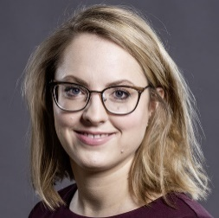

Please welcome the new TRR 241 PI Kristina Koop from the UKER. She will work on “Emergency barriers in Inflammatory Bowel Diseases - Neutrophil-epithelial crosstalk shapes epithelial restitution in the ulcer microenvironment” in project B04 together with Moritz Leppkes.

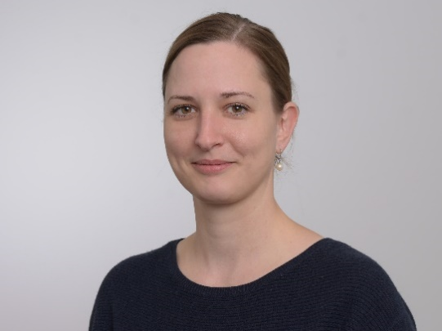

Please welcome the new TRR 241 PI Petra Bacher from the CAU, Kiel. She will work on “Dissecting microbial subcellular structures as targets for specific Treg-based therapies” in project B06 together with Alexander Scheffold.

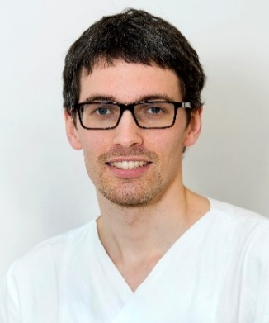

Please welcome the new TRR 241 PI Sebastian Zundler from the UKER. He will work on “Direct and indirect crosstalk of epithelial GPR15L with immune cells via the intestinal microbiome in the pathogenesis of IBD” in project B08.

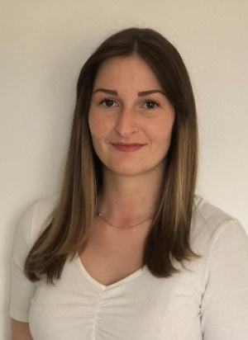

Please welcome our new doctoral students of the TRR 241:

* Sonja Walling (B01)
* Toka Omar (B01)
* Aayushi Shah (B03)
* Johan Kantsjö (B03)
* Patrycja Topczewska (B05)
* Hendrik Grapp (B04)

Please welcome the new TRR 241 secretary Ines Babst! She will work at the Erlangen site and will also be a contact person for the iRTG.

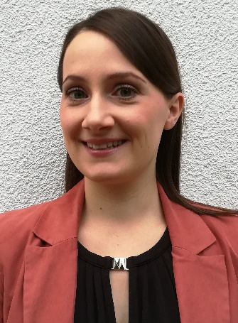

***Congratulations to Magdalena Prüß, who has accepted the professorship for Basic Medical Sciences at the Medical School Berlin!***

* Yu YQ, Thonn V, **Patankar JV**, Thoma OM, **Waldner M**, Zielinska M, Bao LL, Gonzalez-Aceera M, Wallmüller S, Engel FB, **Stürzl M**, **Neurath MF**, Liebing E, **Becker C**. SMYD2 targets RIPK1 and restricts TNF-induced apoptosis and necroptosis to support colon tumor growth. Cell Death Dis. 2022 Jan 12; 13(1):52. doi: 10.1038/s41419-021-04483-0.
* **Prüß MS**, Bayer A, Bayer KE, **Schumann M**, **Atreya R**, Mekle R, Fiebach JB, **Siegmund** B, Neeb L. Functional Brain Changes Due to Chronic Abdominal Pain in Inflammatory Bowel Disease: A Case-Control Magnetic Resonance Imaging Study. Clin Transl Gastroenterol. 2022 Feb 1;13(2):e00453. doi: 10.14309/ctg.0000000000000453. PMID: 35060939
* Heichler C, Schmied A, Enderle K, **Scheibe K**, Murawska M, Schmid B, **Waldner MJ**, **Neurath MF**, **Neufert C**. Targeting STAT3 Signaling in COL1+ Fibroblasts Controls Colitis-Associated Cancer in Mice. Cancers (Basel). 2022 Mar 14;14(6):1472. doi: 10.3390/cancers14061472.
* Hecker J, Letizia M, Loescher BS, **Siegmund B**, **Weidinger C**. [Early Onset of TNFα-Driven Arthritis, Auto-inflammation, and Progressive Loss of Vision in a Patient with ALPK1 Mutation.](https://pubmed.ncbi.nlm.nih.gov/35235128/) J Clin Immunol. 2022 May;42(4):880-884. doi: 10.1007/s10875-022-01214-8. Epub 2022 Mar 2.
* Ahlers J, Mantei A, Lozza L, Stäber M, Heinrich F, **Bacher P**, Hohnstein T, Menzel L, Yüz SG, Alvarez-Simon D, Bickenbach AR, **Weidinger C**, Mockel-Tenbrinck N, **Kühl AA**, **Siegmund B**, Maul J, Neumann C, **Scheffold A**. [A Notch/STAT3-driven Blimp-1/c-Maf-dependent molecular switch induces IL-10 expression in human CD4+ T cells and is defective in Crohn´s disease patients.](https://pubmed.ncbi.nlm.nih.gov/35169232/) Mucosal Immunol. 2022 Mar;15(3):480-490. doi: 10.1038/s41385-022-00487-x. Epub 2022 Feb 15.PMID: 35169232 **Free PMC article.**
* **Atreya R, Bojarski C**, **Kühl AA**, Trajanoski Z, Neurath MF, **Siegmund B.** [Ileal and colonic Crohn's disease: Does location makes a difference in therapy efficacy?](https://pubmed.ncbi.nlm.nih.gov/35345820/) Curr Res Pharmacol Drug Discov. 2022 Mar 19;3:100097. doi: 10.1016/j.crphar.2022.100097.
* **Voskens C**, Stoica D, Rosenberg M, Vitali F, **Zundler S**, Ganslmayer M, Knott H, Wiesinger M, Wunder J, Kummer M, **Siegmund B**, Schnoy E, Rath T, Hartmann A, Hackstein H, Schuler-Thurner B, Berking C, Schuler G, **Atreya R**, **Neurath MF**. [Autologous regulatory T-cell transfer in refractory ulcerative colitis with concomitant primary sclerosing cholangitis.](https://pubmed.ncbi.nlm.nih.gov/35428657/) Gut. 2022 Apr 15:gutjnl-2022-327075. doi: 10.1136/gutjnl-2022-327075. Online ahead of print.
* Stehr AM, Wang G, Demmler R, Stemmler MP, Krug J, Tripal P, Schmid B, Geppert CI, Hartmann A, Muñoz LE, Schoen J, Völkl S, Merkel S, **Becker C**, Schett G, Grützmann R, Naschberger E, Herrmann M, **Stürzl M**. Neutrophil extracellular traps drive epithelial-mesenchymal transition of human colon cancer.J Pathol. 2022 Apr;256(4):455-467. doi: 10.1002/path.5860. Epub 2022 Feb 15.
* Ninnemann J, Winsauer C, Bondareva M, **Kühl AA**, Lozza L, Durek P, Lissner D, **Siegmund B**, Kaufmann SHE, Mashreghi MF, Nedospasov SA, Kruglov AA. T[NF hampers intestinal tissue repair in colitis by restricting IL-22 bioavailability.](https://pubmed.ncbi.nlm.nih.gov/35383266/) Mucosal Immunol. 2022 Apr;15(4):698-716. doi: 10.1038/s41385-022-00506-x. Epub 2022 Apr 5.
* **Hegazy AN**, Krönke J, Angermair S, Schwartz S, **Weidinger C**, Keller U, Treskatsch S, **Siegmund B**, Schneider T. A[nti-SARS-CoV2 antibody-mediated cytokine release syndrome in a patient with acute promyelocytic leukemia.](https://pubmed.ncbi.nlm.nih.gov/35692034/) BMC Infect Dis. 2022 Jun 13;22(1):537. doi: 10.1186/s12879-022-07513-0.
* Golusda L, **Kühl AA**, Lehmann M, Dahlke K, Mueller S, Boehm-Sturm P, Saatz J, Traub H, Schnorr J, Freise C, Taupitz M, Biskup K, Blanchard V, Klein O, Sack I, **Siegmund B**, Paclik D. Visualization of Inflammation in Experimental Colitis by Magnetic Resonance Imaging Using Very Small Superparamagnetic Iron Oxide Particles. Front Physiol. 2022 Jul 12;13:862212. doi: 10.3389/fphys.2022.862212. eCollection 2022.

**New TRR 241 Publications**

* Schweda A, Becker E, Wiendl M, **Atreya R**, **Atreya I**, Müller TM, **Neurath MF**, **Zundler S**. Etrolizumab-s Does not induce residual Trafficking of Regulatory T Cells. Inflamm Bowel Dis. 2022 Jul 11:izac137. doi: 10.1093/ibd/izac137. Online ahead of print.
* Letizia M, Wang YH, Kaufmann U, Gerbeth L, Sand A, Brunkhorst M, Weidner P, Ziegler JF, Böttcher C, Schlickeiser S, Fernández C, Yamashita M, Stauderman K, Sun K, Kunkel D, Prakriya M; IBDome Researchers, **Sanders A**, **Siegmund B**, Feske S, **Weidinger C**. [Store-operated calcium entry controls innate and adaptive immune cell function in inflammatory bowel disease.](https://pubmed.ncbi.nlm.nih.gov/35919953/) EMBO Mol Med. 2022 Sep 7;14(9):e15687. doi: 10.15252/emmm.202215687. Epub 2022 Aug 2.
* Zhang J, **Wirtz S**. Does Pyroptosis Play a Role in Inflammasome-Related Disorders? Int J Mol Sci. 2022 Sep 9;23(18):10453. doi: 10.3390/ijms231810453.
* Masanetz RK, Winkler J, Winner B, **Günther C**, Süß P. The Gut-Immune-Brain Axis: An Important Route for Neuropsychiatric Morbidity in Inflammatory Bowel Disease. Int J Mol Sci. 2022 Sep 21; 23(19):11111. doi: 10.3390/ijms231911111.
* Yu YQ, Gamez-Belmonte R, **Patankar JV**, Liebing E, **Becker C.** The role of Programmed Necrosis in Colorectal Cancer. 2022 Sep 1;14(17):4295.doi:10.3390/cancers14174295.
* Schmalzl A, Leupold T, Kreiss L, Waldner M, Schürmann S, Neurath MF, Becker C, Wirtz S. Interferon regulatory factor 1 (IRF-1) promotes intestinal group 3 innate lymphoid responses during Citrobacter rodentium infection. Nat Commun. 2022 Sep 29;13(1):5730. doi: 10.1038/s41467-022-33326-5.
* Kreiss L, Ganzleben I, Mühlberg A, Ritter P, Scheidereit D, Becker C, Neurath MF, Friedrich O, Schürmann S, Waldner M. Label-free analysis of inflammatory tissue remodeling iin murine lung tissue based on multiphoton microscopy, Raman spectroscopy and machine learning. J Biophotonics. 2022 Sep; 15(9):e202200073.doi: 10.1002/jbio.202200073. Epub 2022 Jun 26.
* Schneider I, Allner C, Mühl L, Melde M, Lissner D, Mantzivi E, Glauben R, Vitali F, Becker E, **Atreya I**, Müller T, **Atreya R**, **Siegmund B**, **Neurath MF**, **Zundler S**. Transl Res. [Expression and function of α4β7 integrin predict the success of vedolizumab treatment in inflammatory bowel disease.](https://pubmed.ncbi.nlm.nih.gov/36272713/) 2022 Oct 19:S1931-5244(22)00222-5. doi: 10.1016/j.trsl.2022.10.003. Online ahead of print.PMID: 36272713

Please send newly accepted TRR 241 publications to [mailto:Ines.Babst@uk-erlangen.de; erika.von-buehler@charite.de?subject=Publications TRR 241](mailto:Ines.Babst@uk-erlangen.de;%20erika.von-buehler@charite.de?subject=Publications%20TRR%20241)